Test Case: tc006_SPX_Dev5_Crear_Requisicion_Spot_Tipo_Cobro_Proyect_Urgent
Step 1 - Enter username and password and click to button Enter: Credentials Entered
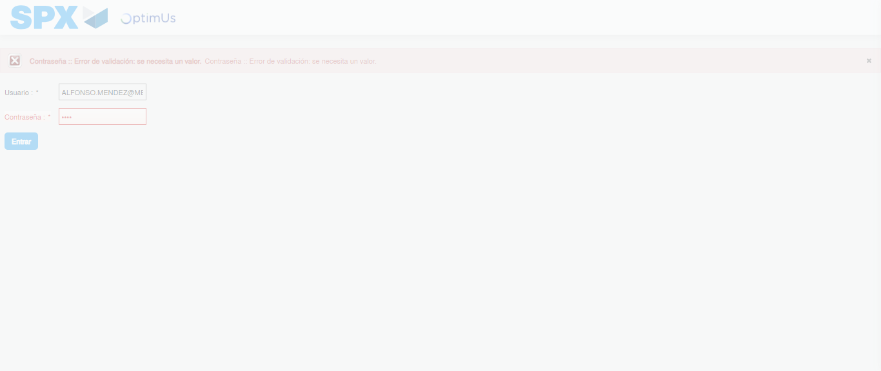Image file-name: QC_Testing-tc006_SPX_Dev5_Crear_Requisicion_Spot_Tipo_Cobro_Proyect_Urgent-1783376879803

Step 2 - Select to UEN and Access to Spot Buy Requisitions : UEN Correctly selected and Correct access
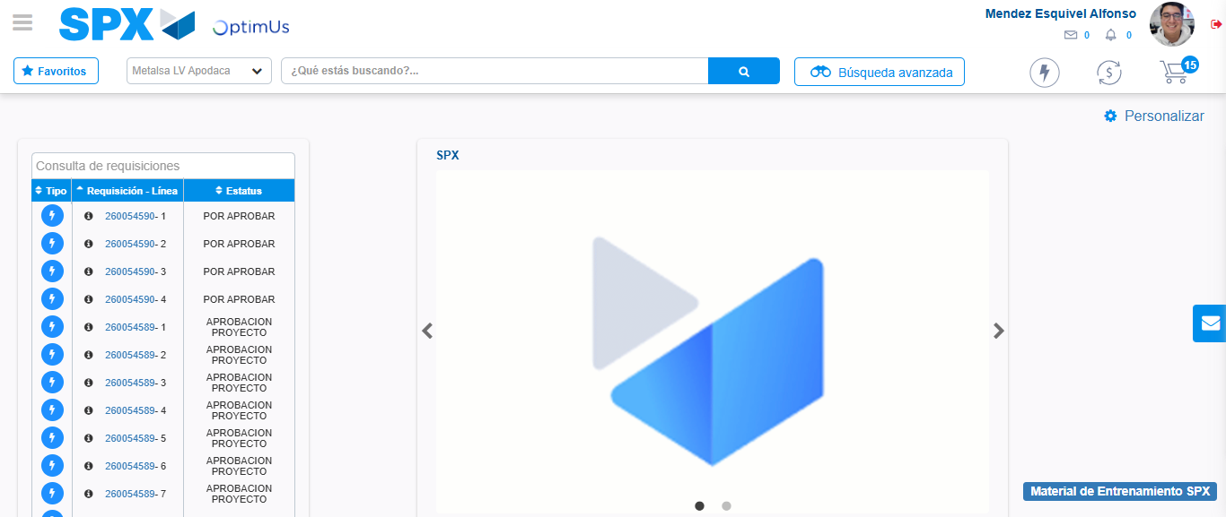Image file-name: QC_Testing-tc006_SPX_Dev5_Crear_Requisicion_Spot_Tipo_Cobro_Proyect_Urgent-1783376905979

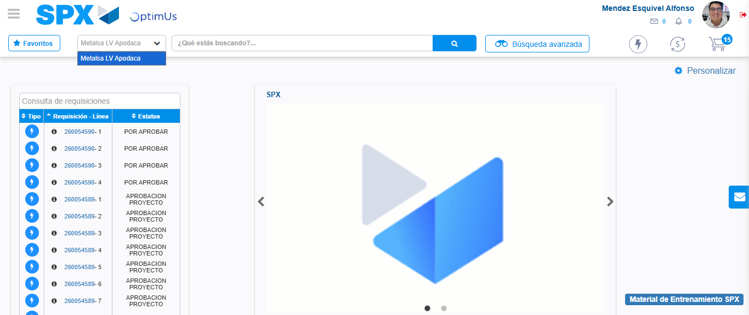Image file-name: QC_Testing-tc006_SPX_Dev5_Crear_Requisicion_Spot_Tipo_Cobro_Proyect_Urgent-1783376908486

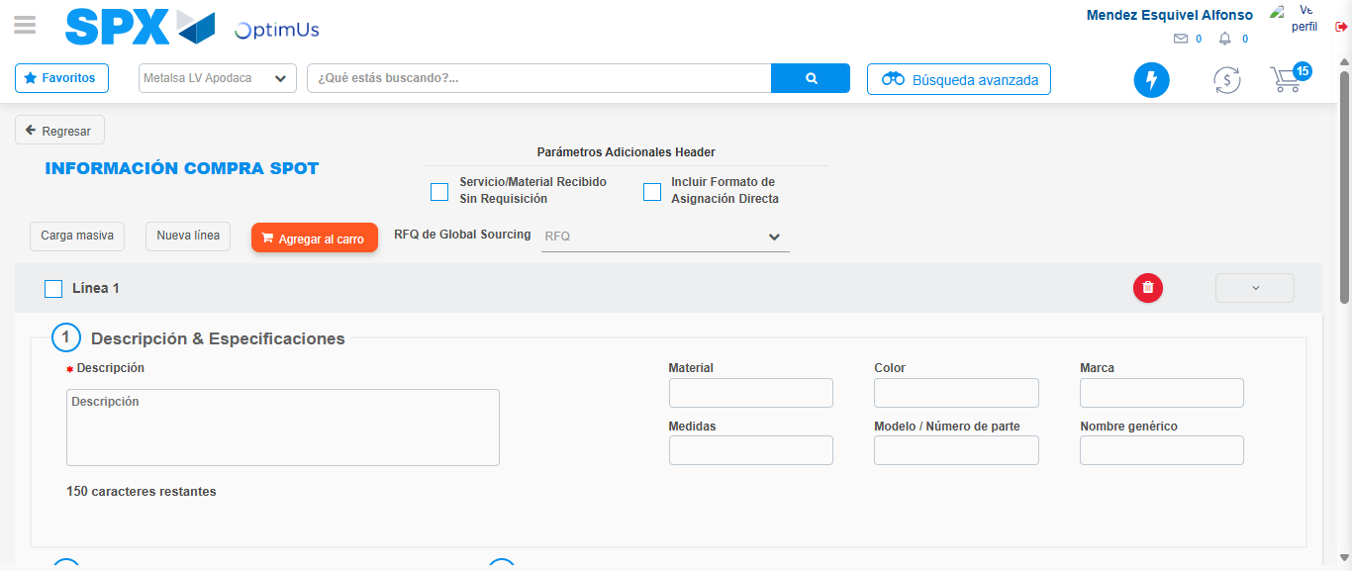Image file-name: QC_Testing-tc006_SPX_Dev5_Crear_Requisicion_Spot_Tipo_Cobro_Proyect_Urgent-1783376925636

Step 3 - Data Capture Spot Buy Requisition: Data captured correctly
Image file-name: QC_Testing-tc006_SPX_Dev5_Crear_Requisicion_Spot_Tipo_Cobro_Proyect_Urgent-1783376925870

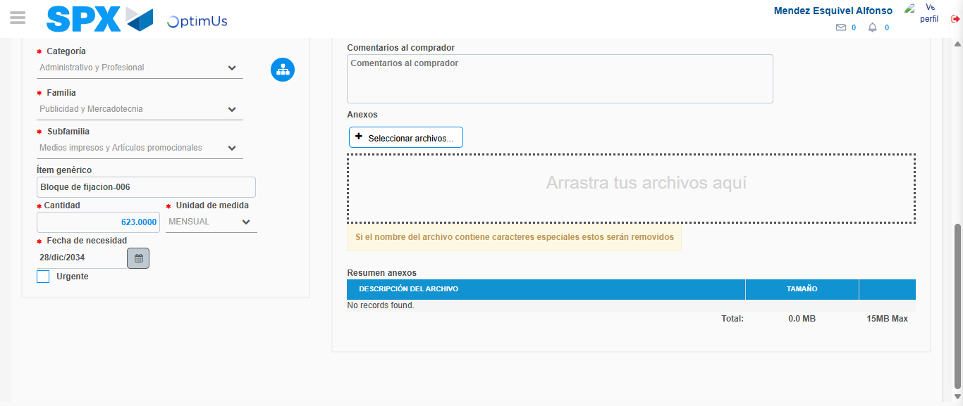Image file-name: QC_Testing-tc006_SPX_Dev5_Crear_Requisicion_Spot_Tipo_Cobro_Proyect_Urgent-1783376935866

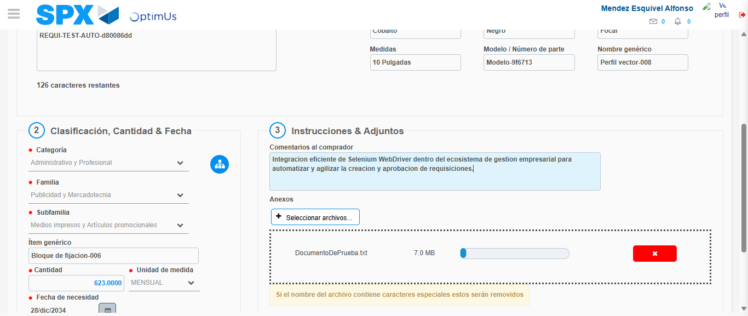Image file-name: QC_Testing-tc006_SPX_Dev5_Crear_Requisicion_Spot_Tipo_Cobro_Proyect_Urgent-1783376936645

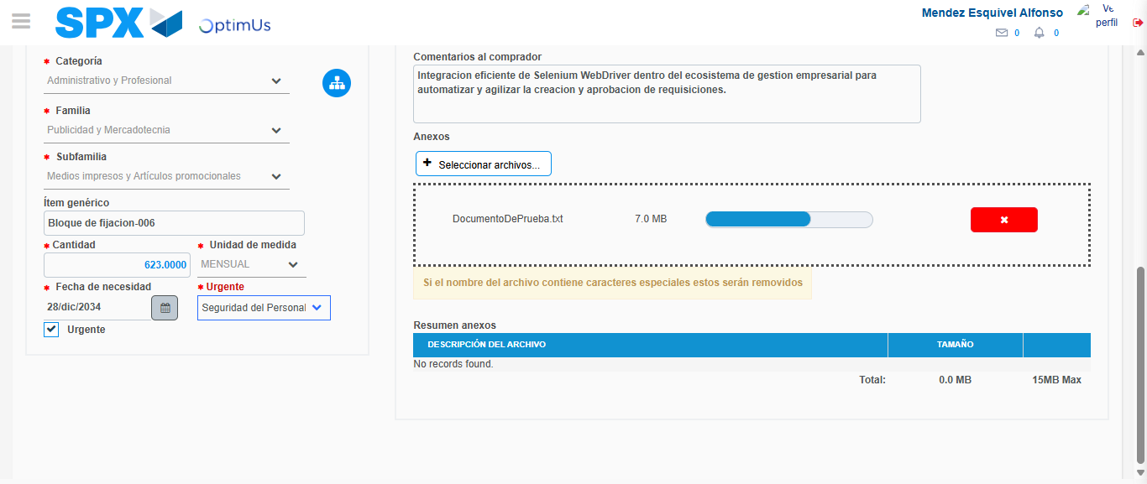Image file-name: QC_Testing-tc006_SPX_Dev5_Crear_Requisicion_Spot_Tipo_Cobro_Proyect_Urgent-1783376940876

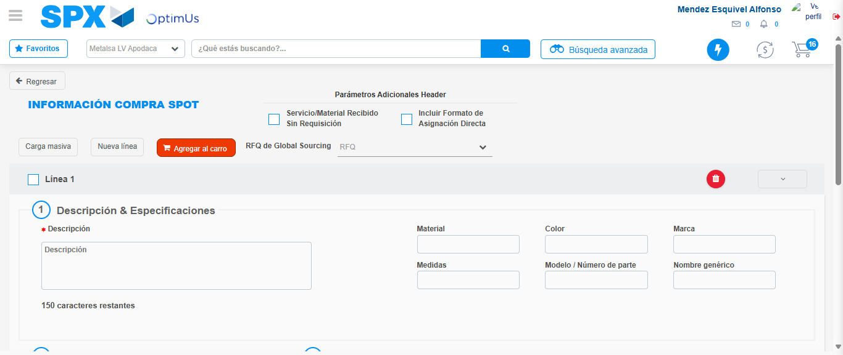Image file-name: QC_Testing-tc006_SPX_Dev5_Crear_Requisicion_Spot_Tipo_Cobro_Proyect_Urgent-1783376945298

Step 7 - Return to Main Page SPX : Return to Main Page SPX
Image file-name: QC_Testing-tc006_SPX_Dev5_Crear_Requisicion_Spot_Tipo_Cobro_Proyect_Urgent-1783376905979

Image file-name: QC_Testing-tc006_SPX_Dev5_Crear_Requisicion_Spot_Tipo_Cobro_Proyect_Urgent-1783376908486

Image file-name: QC_Testing-tc006_SPX_Dev5_Crear_Requisicion_Spot_Tipo_Cobro_Proyect_Urgent-1783376925636

Image file-name: QC_Testing-tc006_SPX_Dev5_Crear_Requisicion_Spot_Tipo_Cobro_Proyect_Urgent-1783376947513

Image file-name: QC_Testing-tc006_SPX_Dev5_Crear_Requisicion_Spot_Tipo_Cobro_Proyect_Urgent-1783376947721

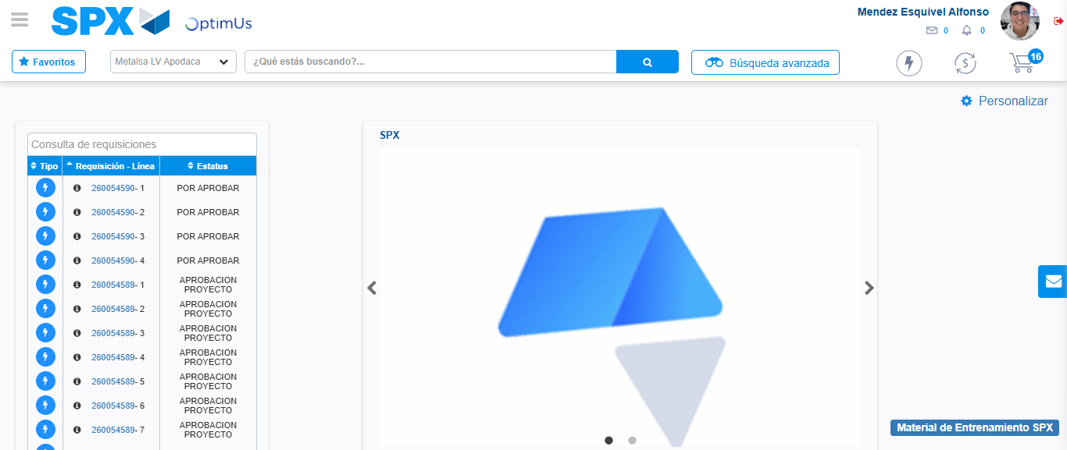Image file-name: QC_Testing-tc006_SPX_Dev5_Crear_Requisicion_Spot_Tipo_Cobro_Proyect_Urgent-1783376968733

Step 8 - Log Out : Log Out SPX
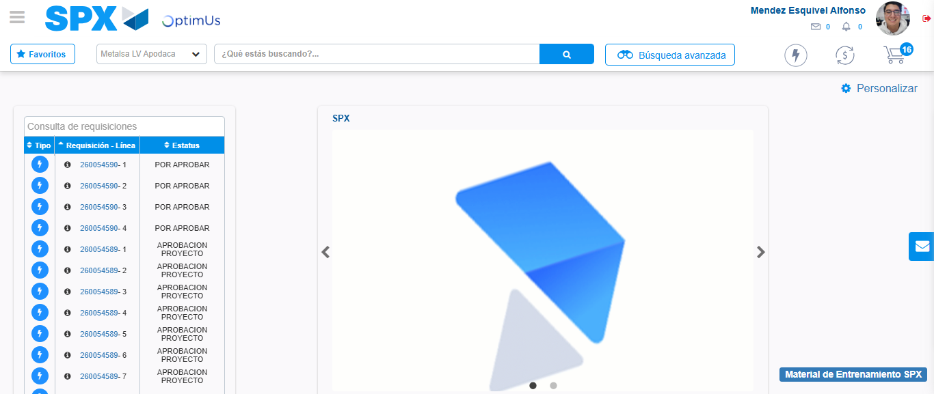Image file-name: QC_Testing-tc006_SPX_Dev5_Crear_Requisicion_Spot_Tipo_Cobro_Proyect_Urgent-1783376968949

